Expt:8
Q1. write a python program to create file in python and some data
Code:
#write a python program to create file in python and some data
file=open("abc.txt","w")
file.write("gauresh")
file.close()
output:
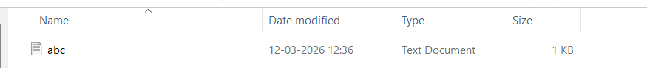

Q2.read a data from file using python
Code:
file=open("abc.txt","r")
a=file.read()
print(a)
file.close()
output:
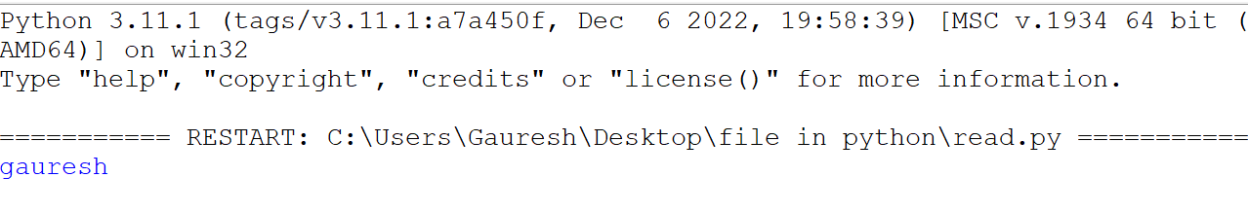

Q3.write a data in file using user input in python.
Code:
file=open("abc1.txt","w")
a=input("enter a data: ")
file.write(a)
file.close()
output:
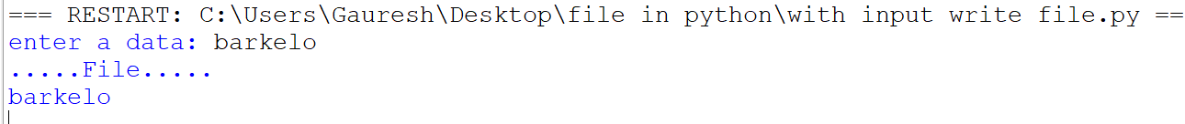

Q4.Translator in python
Code:
from googletrans import Translator
translator = Translator()
text = input("Enter Text:")
language=input("select language : ")
translated=translator.translate(text,dest=language)
print("Original Text:", text)
print("Translated Text:", translated.text)
output:
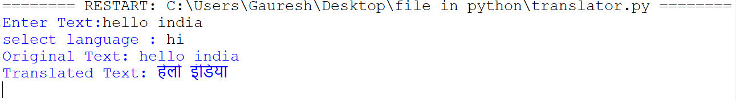

Q5 Sentiment
Code :
from textblob import TextBlob
text = input("Enter a sentence: ")
analysis = TextBlob(text)
polarity = analysis.sentiment.polarity
if polarity > 0:
print("Sentiment: Positive 😊")
elif polarity < 0:
print("Sentiment: Negative 😞")
else:
print("Sentiment: Neutral 😐")
print("Polarity Score:", polarity)
output:
